A coalescing ring buffer is a specialized data structure based on the classic ring buffer (or circular buffer) with the additional ability to combine (or coalesce) multiple queued elements into a single one under certain conditions. This is particularly useful in systems that process messages, events, or data streams where aggregation of similar or redundant items can optimize processing.

How a Coalescing Ring Buffer Works
- Classic Ring Buffer Basics:
  - A fixed-size buffer operates in a circular manner.
  - Two pointers are maintained:
    - Head: Points to where data will be read.
    - Tail: Points to where new data will be written.
  - When the buffer is full, adding a new element overwrites the oldest one.
- Coalescing Behavior:
  - Instead of overwriting, the buffer checks if the incoming data can be merged with existing data already in the buffer.
  - This can prevent redundant storage and reduce processing overhead by condensing multiple similar operations.

Use Cases
- Event Queues:
  - In GUIs or systems that process frequent updates (e.g., mouse movements, screen refreshes), coalescing can aggregate multiple intermediate updates into a single effective update.
- Network Buffers:
  - For throttling or batching requests where redundant network messages (e.g., repeated state updates) can be consolidated.
- Logging or Telemetry:
  - Coalescing log entries or metrics to avoid flooding the system with unnecessary or redundant data.

Implementation Outline
Here’s a conceptual implementation of a Coalescing Ring Buffer in Java:

1. Data Structure
Define the buffer and the coalescing logic:
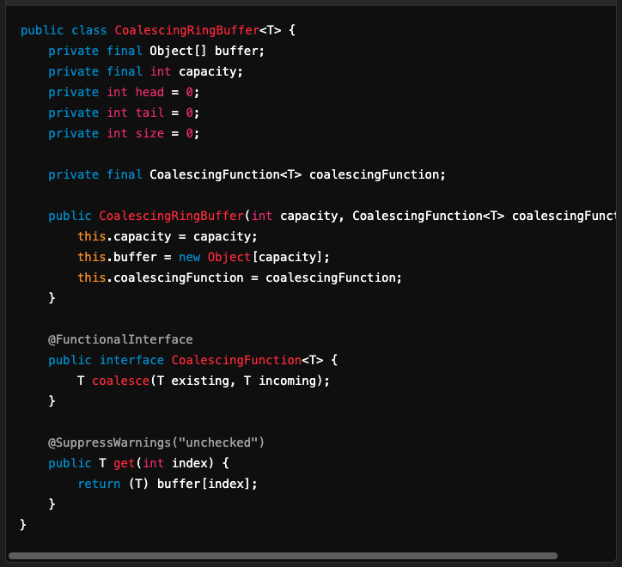

2. Add Items with Coalescing
Handle data addition, ensuring coalescing logic applies:
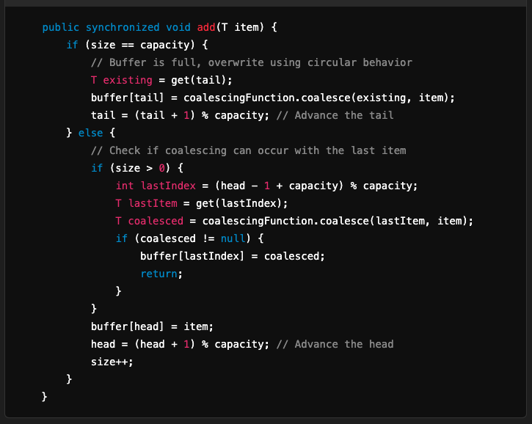

3. Read Items
Read and remove items from the buffer:
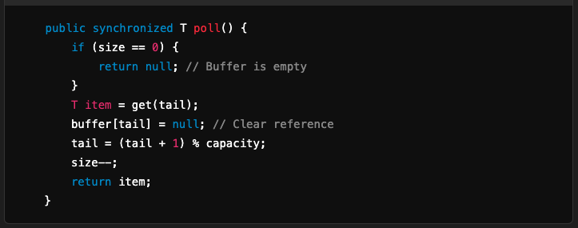

4. Example Usage
Use the buffer with a coalescing function:
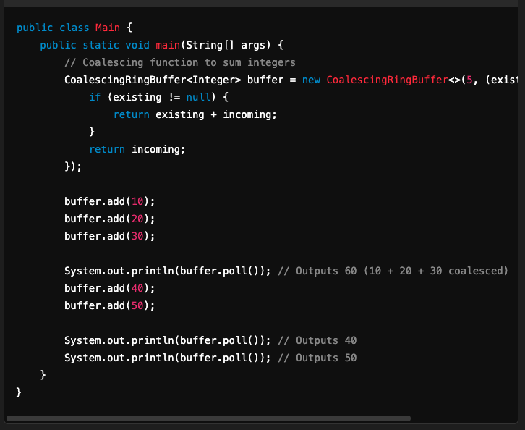

Key Considerations
- Coalescing Logic:
  - The behavior of the coalescingFunction defines how data is combined. It can be as simple as summing numbers or as complex as merging custom objects.
- Thread Safety:
  - Ensure thread-safe operations if the buffer is accessed concurrently.
- Capacity Management:
  - The buffer should gracefully handle overflow by overwriting or rejecting new elements based on requirements.
- Memory Management:
  - Clear references to objects after use to prevent memory leaks.

Advantages
- Reduces redundant operations by merging similar or repeated entries.
- Optimizes memory usage and processing in systems with high-frequency updates.
- Improves overall system performance in event-driven or streaming systems.

Disadvantages
- Coalescing logic adds overhead to the basic ring buffer operations.
- Loss of granularity due to merging, which might not be suitable for all applications.

This implementation offers a flexible way to combine the benefits of circular buffers with data aggregation or reduction techniques.

